Aligning ESTs to Genome Using Multi-Layer Unique Makers

F. R. Hsu and J. F. Chen
IEEE Computer Society Bioinformatics Conference, pp. 564-566, 2003

Abstract

A unique marker (UM) is a sequence appeared in genome only once. We can locate the position of ESTs in genome by finding unique markers contained in ESTs. The time complexity to align ESTs to genome grows rapidly when we use longer unique markers. The method has the benefit of both short and long unique markers.

- Introduction

EST are tags made by cDNA single pass of each lab, so they are the part of genome that finally will be translated into protein with length about 600 bps. Let 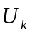denote the set of unique markers of G with length k. The larger of k, the probability of E contains any elements in is higher. Yet, the larger of k, the number of elements in is more.

2. Multi-layer unique markers

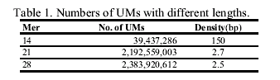

For human genome, we construct 3-layer unique markers as follow. The three layers consist of 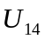, 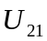, 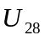 respectively. Element in are sorted in the first layer. Each entry of the first layer consists of three fields: the UM, the position of UM in genome and a pointer points to the next layer.

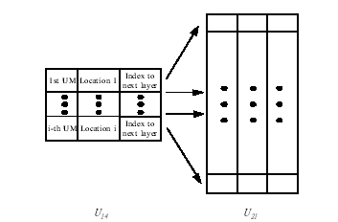
- Locating SNPs on genome

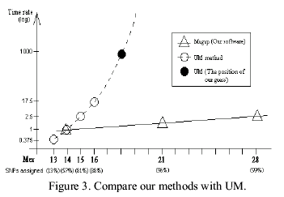
- Aligning ESTs to genome

Step 1. Locate E on G by using multi-layer UMs.
Step 2. Extend matched unique markers.
Step 3. Find more matched area.
Step 4. Align unmatched area.
Step 5. Process repetitive sequences.
Step 6. Detect spliced sites. GT-AG rule SpliceDB
Step 7. Try 3’ strand.

Created by: Chia-Chang Wang
Date: Feb. 25, 2004

